Report for Placement Data

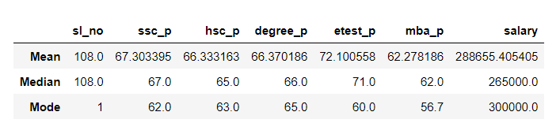

* In this Report ,all the students score average range 60 mark in ssc to degree ,but in the entrance test alone they scored 70 as a good range ,so I found there is an outlier in the salary part.
* All the students got salary 288655,but ouliers found in median part salary as 265000
* The repeated marks scored in ssc is 62 , Hsc marks is 63 and in degree 65,Engrance test is 60.
* The salary of the students who scored repeated marks as 62,63,65,60 in ssc ,Hsc ,degree, etest got salary range 300000